What are the Common Symptoms?
Two most common symptoms of mouth cancer are:
- An ulcer in your mouth which does not heal (80% of sufferers had these symp- toms).
- Ongoing pain or discomfort.

Other symptoms can include:
- White or red patch in the mouth or throat that will not go away.
- A lump of thickening on the lip, or in the mouth or throat.
- Difficulty in chewing or moving the jaw or tongue.
- Unusual bleeding or numbness of the tongue or mouth.
- Loose teeth for no apparent reason.
- Speech problems or a chronic sore throat that persists more than six weeks.
- A lump in the neck or neck swelling pre- sent more than three weeks.
- Weight loss.
- Bad breath (halitosis)
- Unexplained earache.

In order to ensure early signs are spotted, you should have regular check-ups with your dentist and dental hygienist. If there are any suspicious signs, we will refer you to an ap- propriate Specialist for immediate investiga- tions.
For more information relating to Oral Cancer you can also contact the following organisa- tions:

Mouth Cancer Foundation
PO Box 498
Wakefield West Yorkshire WF1 9AW
Helpline: 01924 950 950
Email: info@mouthcancerfoundation.org website: www. mouthcancerfoundation.org or

Cancer Research UK www.cancerresearchuk.org freephone number: 0808 800 4040

PRACTICE CONTACT
Specialist Dental Services 94 Harley Street
London W1G7HX

Phone: 020 7580 4200
Fax: 020 7636 6036
Email: Smile@SpecailistDentalServices.com Website: www.SpecialistDentalServices.com

Patient Information for
Oral Cancer

www.Smile@SpecialistDentalServices.com

Patient Information - Oral Cancer
For More Information or to arrange an Oral Cancer Assessment, Please call 0207 580 4200

What is Oral Cancer?
Oral Cancer or ‘Mouth and Oropharyngeal Cancer’ is a type of cancer that can affect your mouth (medical term oral cavity) or your throat (Pharynx).
  - Mouth cancer can start anywhere in our oral cavity. For example on the lips, inside
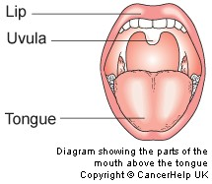
the lining of the cheeks and gums, on the roof or floor of the mouth, the tongue and the ar- ea behind your wisdom teeth.

    - Throat (Pharynx) are divided into 3 parts. The first part is directly connected to your mouth and is also
called ‘Oropharynx’. This part includes our tonsils, soft area of the roof of your mouth,
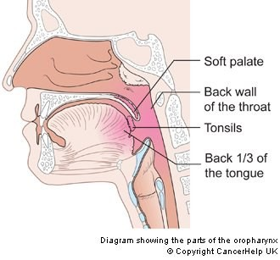
the back third of your tongue and the back wall of your throat.

Both your throat and mouth help you breathe, talk, swallow and eat!

How can you avoid mouth and Throat cancer?
It is actually very easy to prevent by taking the following action:
- Having a healthy lifestyle.
- Good Diet and exercise.
- Avoiding tobacco such as smoking or chewing tobacco or betel quid.
- Avoiding high alcohol use.
- Avoiding casual ‘open mouth’ kissing and oral sex if you have different sexu- al partners.
The two main risk factors for oral cancer in the Western World are:

SMOKING AND ALCOHOL!
Both contain chemicals known as nitrosamines and these are known to cause cancer. The chemicals in alcohol pass over the mouth, throat and top of the larynx as you swallow. The alcohol consumption increases the risk of oral cancer. For example, if you drink 100g/day, you have a 4-6 fold increased risk of oral cancer and other types of cancer than somebody who is a light or non- drinker.
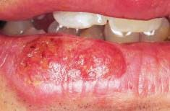
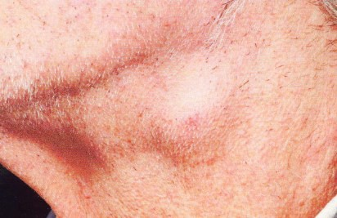
The Alcohol Content of Some Common Drinks
Alcoholic Drink | Grams of alcohol
A pint of ordinary strength larger | 16 grams
A pint of strong larger (Stella Artois, Kronenbourg 1664) | 24 grams
A pint of ordinary bitter (John Smith’s, Boddingtons) | 16 grams
A pint of best bitter (Fuller’s ESB, Young’s Special) | 24 grams
A pint of ordinary strength cider (Woodpecker) | 16 grams
A pint of strong cider (Dry Blackthorn, Strongbow) | 24 grams
A 175ml glass of red or white wine | 16 grams
A pub measure of spirits | 8 grams

Smoking a cigarette affects the mouth as the smoke passes through the mouth, throat and the larynx on its way to the lungs.

The longer you smoke, the higher the risk of
Cancer!
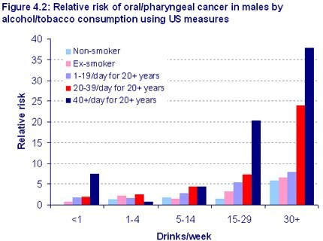

The following are pictures of ulcers affecting the mouth that could be cancerous and Could need urgent referral.
